BRITAIN QUIZ 1.
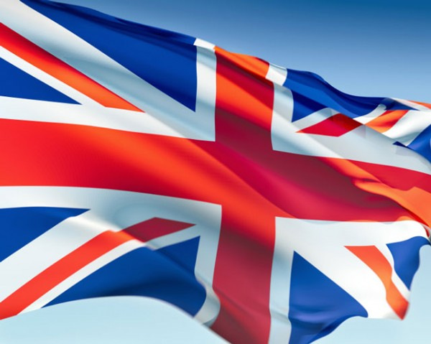
CHOOSE THE CORRECT ANSWER AND FILL IN THE ANSWER SHEET!
- What is the capital city of Wales?
- Belfast
- London
- Cardiff
- Edinburgh

- What is Stonehenge?
- a castle
- a monument
- a rock
- a church

- Where is Stonehenge situated?
- Near Liverpool
- North of Salisbury
- In the Highlands
- At Loch Ness

- Which is the longest river in England?
- The Mersey
- The Thames
- The Severn
- The Thyne

- What is Ben Nevis?
- a river
- a lake
- a mountain
- a cliff

- Where is Ben Nevis?
- England
- Scotland
- Wales
- Northern Ireland

- An iessteddfod is a festival for….
- cooking
- dancing
- doing sports
- singers and poets

- Which animal can be seen in the Welsh flag?
- lion
- eagle
- dragon
- monkey

- What CANNOT you eat in a traditional Christmas pudding?
- raisins
- suet
- cinnamon
- raspberry

- What is the lamp of Haloween called?
- Jack-O-Lantern
- Joe-O-Lantern
- James-O-Lantern
- Judy-O-Lantern

- What is the form of state in Great Britain?
- kingdom
- union
- constitutional monarchy
- parliamental monarchy

- Which meal is English?
- Chicken Curry
- Paela
- Colcannon
- Stargazey pie

- Who is the patron saint of Scotland?
- St. Patrick
- St. David
- St. George
- St. Andrew

- What is a kilt?
- a skirt
- a sword
- a knife
- a meal

- Who wear kilts?
- young girls
- men in Scotland
- football players
- old ladies

- What do people celebrate at Hogmanay?
- New Year’s Eve
- New Yea’rs Day
- 31st December
- 1st January

- What is Happy Hour?
- time of day when people feel happy
- time for sales
- time for resting
- time when alcoholic drinks are sold at a reduced price

- Who is regarded as the greatest dramatist of all time?
- John Osborne
- Daniel Defoe
- William Shakespeare
- John Milton

- Which sport was invented in England?
- golf
- chess
- cricket
- football

- What is the UK surrounded by?
- the Indian Ocean, with the North Sea in the east and the English Channel in the south
- the Atlantic Ocean, with the North Sea in the east and the English Channel in the south
- the Pacific Ocean, with the North Sea in the east and the English Channel in the south
- the Atlantic Ocean, with the North sea in the south and the English Channel in the east

